Activity 1: Org Chart Generator

Create a program that will generate an organizational chart. User must be able manage position names and its parents.

Requirements:

* Layout must be mobile responsive (No Bootstrap)
* PHP (OOP – Object Oriented Programming), HTML, CSS, JS, JQuery, AJAX, MySQL must be used **\*Bonus: Use CodeIgniter Framework (MVC)**
* Well-written and well-designed layout
* Secured in SQL Injection
* CRUD (Create, Read, Update, Delete)

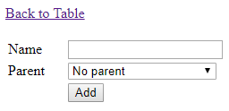

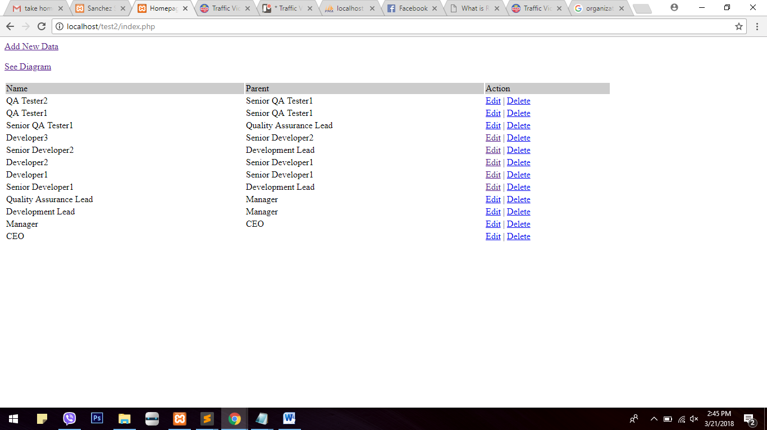

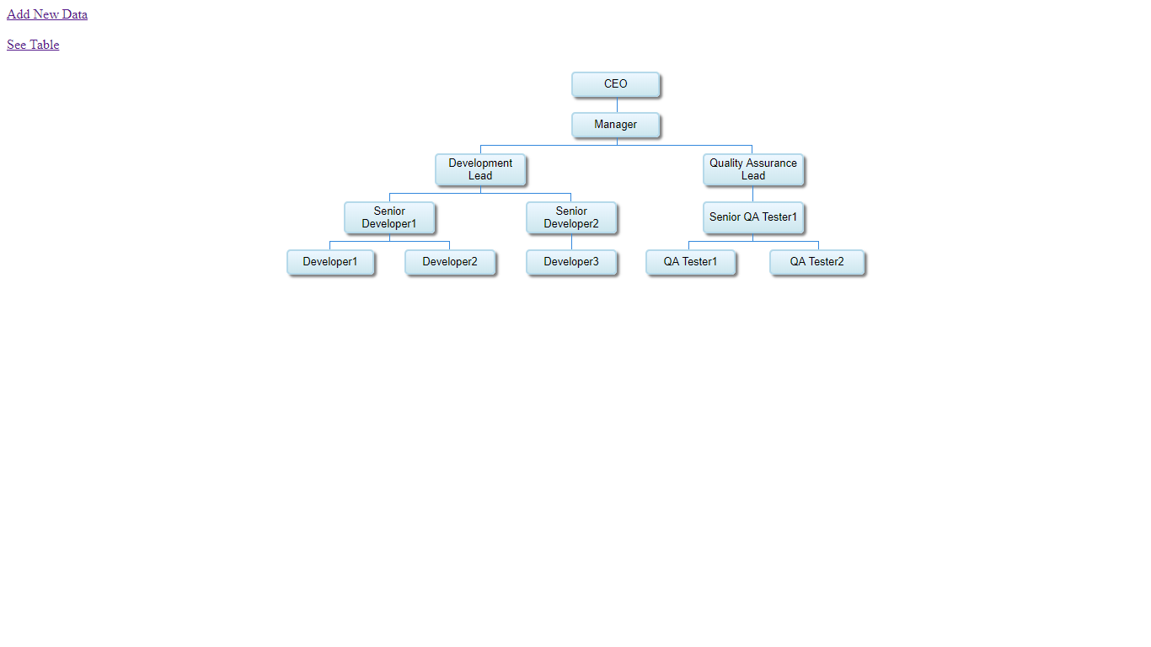

Activity 2: Random Spiral

Create/draw a spiral using randomly generated alphanumeric string. Alphanumeric string must be generated using a two-dimensional array with the following instructions:

* The main array can contain random number of sub-arrays (min 5 – max 10)
* Each sub-array can have random number of indices (min 5 – max 10)
* Each index can have random number of alphanumeric values (min 5 – max 10)
* Each alphanumeric value can have random length (min 5 – max 10)
* Concatenate each alphanumeric value sequentially and form a spiral

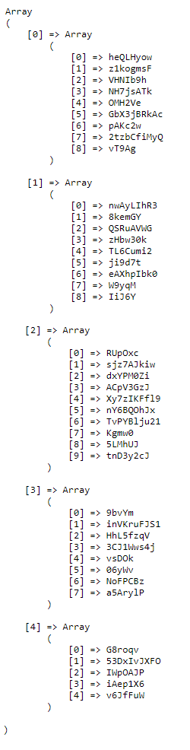

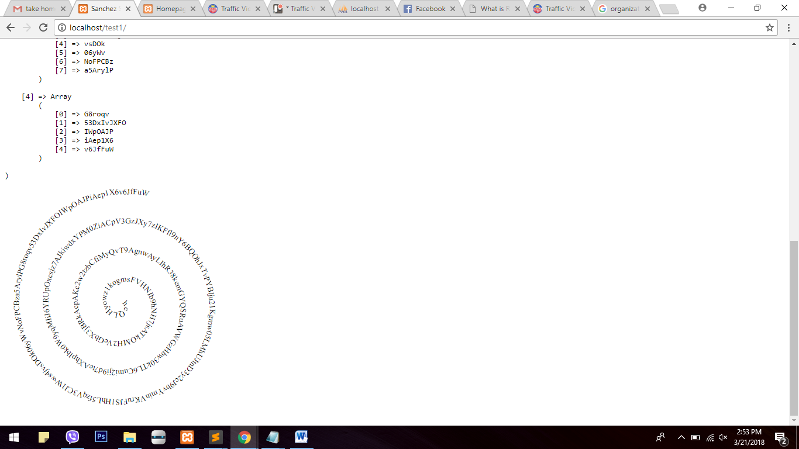

Requirements:

* Every page reload must display a different spiral
* Layout must be mobile responsive (No Bootstrap)
* PHP (OOP – Object Oriented Programming), HTML, CSS, JS, JQuery must be used

**\*Bonus: Use CodeIgniter Framework (MVC)**

* Well-written and well-designed layout
* Maximum use of 2 loops only
* No plugin